DC motor door controller

By Kevin

Contents

Block diagram

Component describes

Power supply unit

Microcontroller

Motor driver and motor

Real time clock

EEPROM

LCD

Keypad

Photoresistor (LUX sensor)

Reed switch

Hall effect sensor

Schematic

Bill of Materials

Print circuit board

Current shunt

Difference amplifier

Comparator

Build and testing

Code

## Block diagram

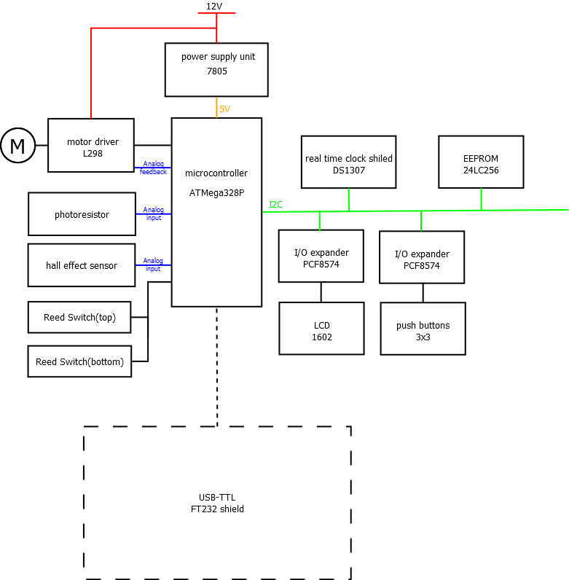

## Component describes

### Power supply unit

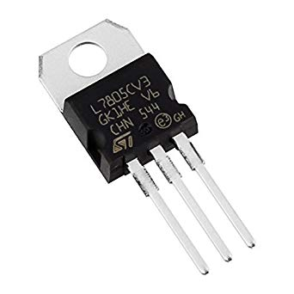

The circuit is designed to be powered by 12V, but the micro controller and sensors are using 5V, so we need a Power supply unit to step down the voltage form 12V to 5V. I pick up a LM7805, this is one of the most popular voltage regulator, it is cheap and easy to configure.

### Microcontroller

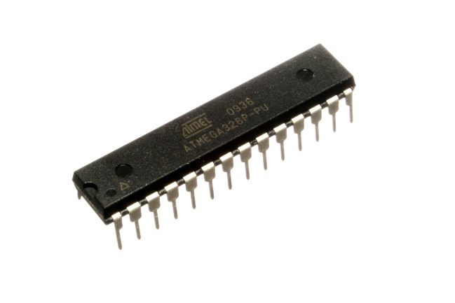

Microcontroller is the brain of the circuit, all the input feed into the microcontroller, be processed and control the door open or close. I use an At mega 328P because it is the same chip as Arduino Uno so I has so many libraries can use, and it has duel inline package so it is easy to solder and fault find.

### Motor driver and motor

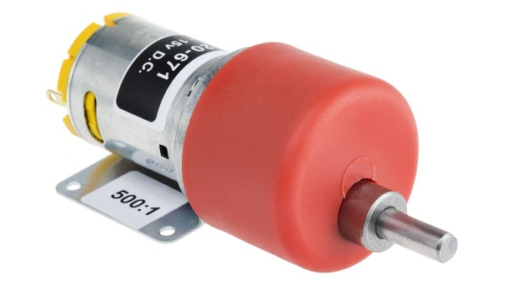 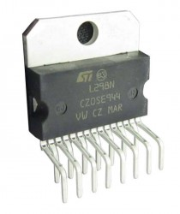

Because the motor is drive by big current, so it can not directly connect to microcontroller, that’s why we need a motor driver. L298N is one of the most wildly use motor driver IC for small motor, it has 2 channels and each channel can handle up to 2A current, more over it has Multiwatt15 package so it is easy to solder and fault find.

The Motor that I pick up is a DC motor with 500:1 gear box. It is slow but very high torque.

### Real time clock

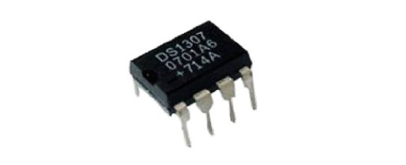

The door can be set to open and close at certain time, so it needs a real time clock. DS 1307 is a low-power RTC base on I2C bus, it masks it externally easy to wires and use. And it will connect to a battery as a backup power supply to keeping the counter running while the main power supply is off.

### EEPROM

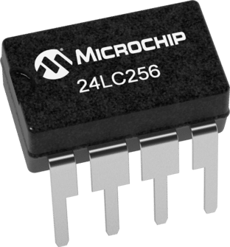

electrically erasable programmable read-only memory can be used to log the door operation and daylight-saving information. 24LC256 is a 256Kb EEPROM comes with the RTC shield.

### LCD

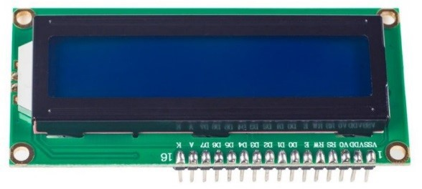

The door controller would need thing to show people what is its status, an LCD is a good idea. 1602 is what I like, I have use it before and Arduino has library for it. What I don’t like is it have to using at least 6 I/O, so I use a PCF8574 I/O expander, it can expand 8 I/O via I2C bus, and most importantly, Arduino has library for that.

### Keypad

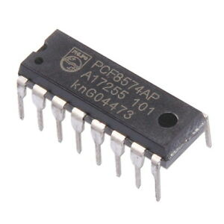

The door controller would need thing to interact with human, that is why I put a keypad into my project. It can be used to manually operate the door and change setting in programming mode. That’s why I put a 3*3 keypad, because it can use to input number 1-9 and arrow key. Due to a 3*3 keypad would need at least 6 I/O, so I use a PCF8574 I/O expander.

### Photoresistor (LUX sensor)

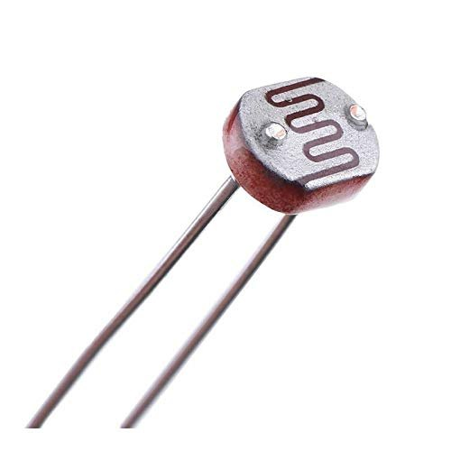

LUX sensor can be one of the sensors to determine when the door should open or close. A photoresistor is cheap, reliable and easy to use. It changes the resistance according to the light, I put it into a voltage divider and get the reading.

### Reed switch

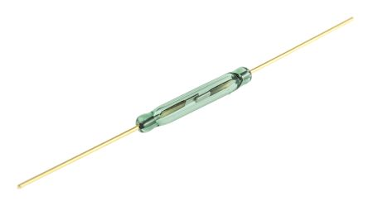

Although a DC motor is cheap and easy to drive, we can accurately control the door’s position, that is why I put a reed switch on the top and bottom of the door. When the reed switch engages, the microcontroller will stop the motor.

### Hall effect sensor

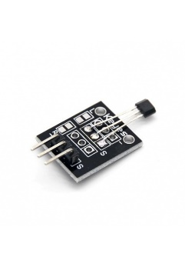

Although we have reed switch to detect the door’s position, it is better to have another sensor to be double safety factor also to detect the door is jammed or not. That is why I include a hall effect sensor in my project. We put a magnetic on the wheel, when the door is opening, the magnetic rotate and cut the magnetic field regularly, the hall effect sensor can receive this signal. When this signal lost, the microcontroller will know the door is jammed and taking action to stop the motor.

## Schematic

## Bill of Materials

## Print circuit board

## Current shunt

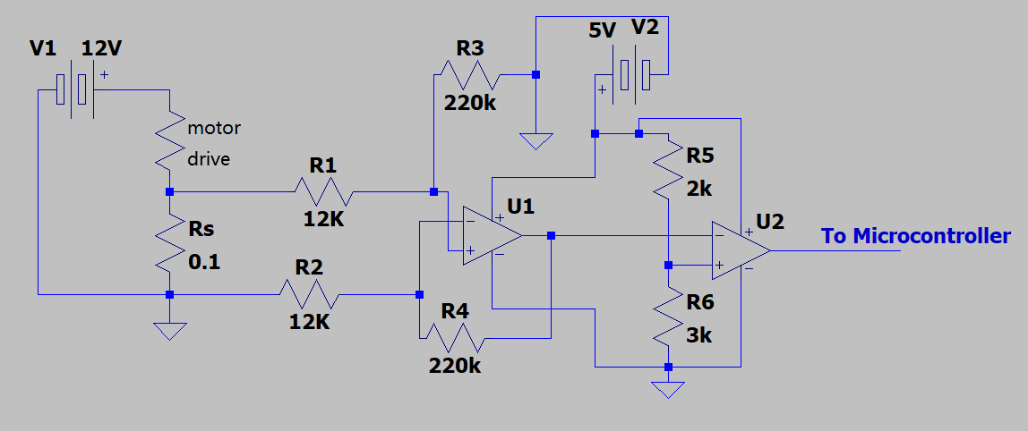

The current is a difference amplifier and a comparator. The shunt resister is series with the motor drive, so the voltage drop is direct proportion to the current. and according to the datasheet, the l298N can handle 2A of current.

### Difference amplifier

$$when R1=R2,R3=R4, V_{out}=\frac{R3}{R1}\left(V_{non-inverting }-V_{inverting }\right) \\ \overset{⇒}{}gain= \frac{220K}{12K}=18.3 \\ V_{shunt}=IR=1.6×0.1=0.16V \\ V_{out}=0.15V×18.3= 2.93V$$

### Comparator

That is a penitential divider on the non-inverting input of the op amp as a setting voltage, when the input voltage of the inverting input is lower than the setting voltage, it will output supply voltage(5V), but when it is higher than the setting voltage, it will pull to grand; it is acting as a extremal interrupt on the microcontroller, when the microcontroller receive this signal it will stop the motor rotating to prevent further damage.

$$setting voltage= V_{in}×\frac{R6}{R5+R6}=3V$$

**Therefor, when current is bigger than 1.6A, the motor will be stopped.**

## Build and testing

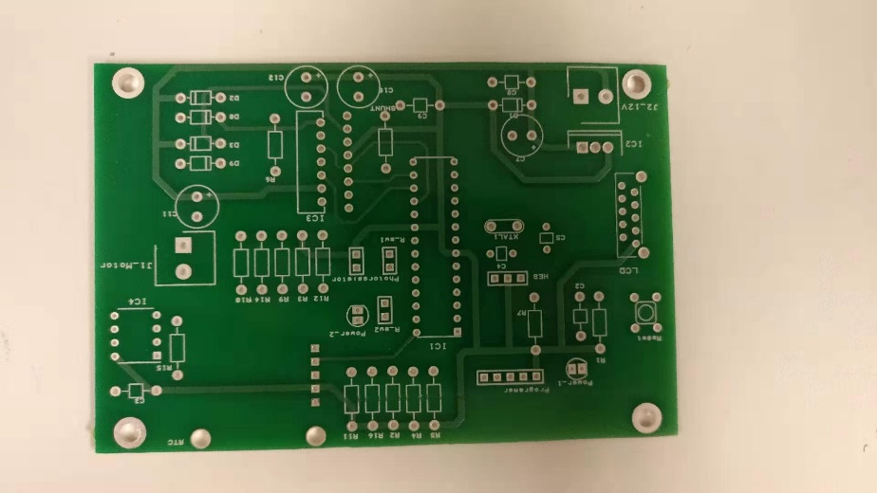

Figure 1 PCB

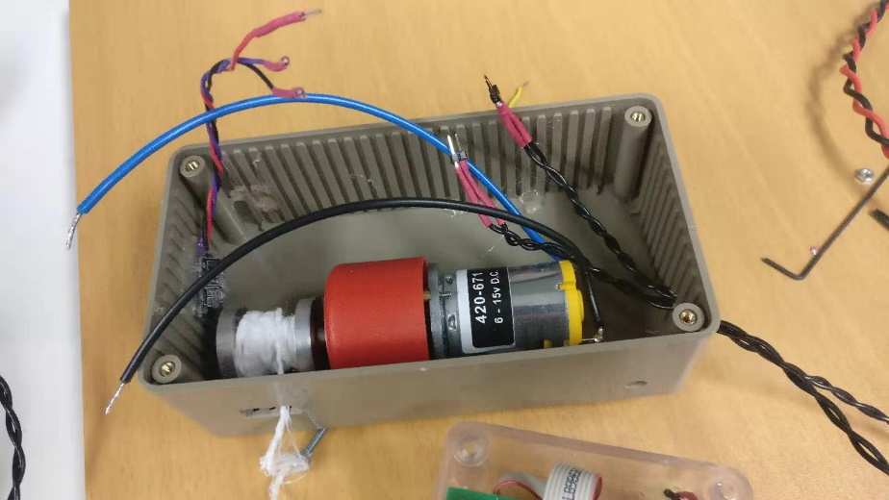

Figure 2 interior

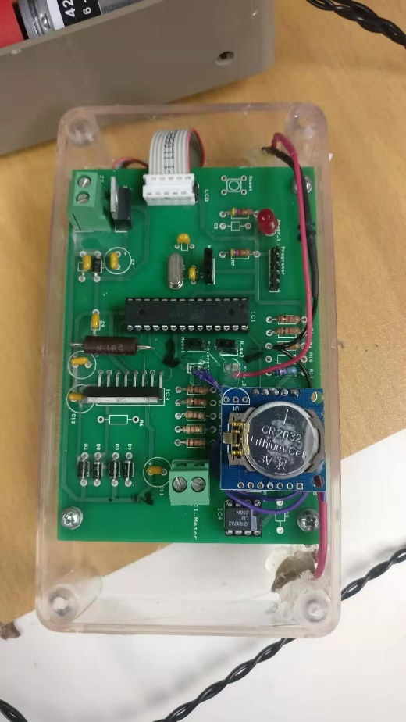

Figure 3 interior

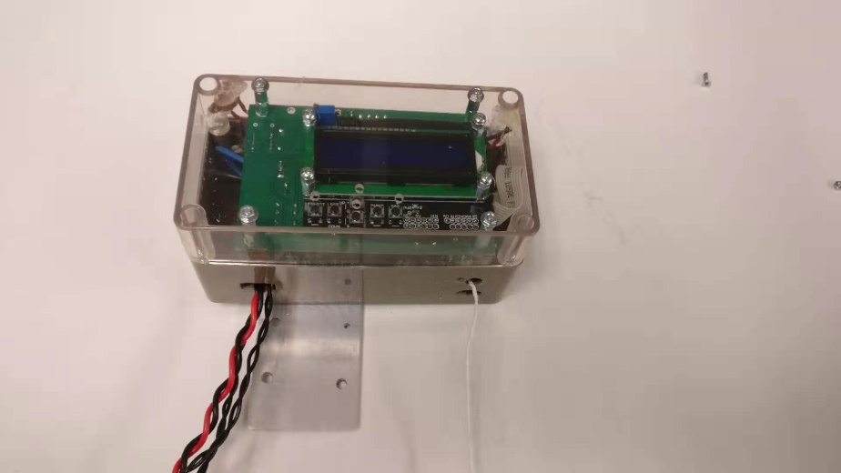

Figure 4 final product

## Code